I'm seeing a lot of people having issues loading their Vault 2012 extension, so here is an updated deployment checklist. The 2011 version of the checklist is here.
For all extension types (custom commands/tabs, job handlers, event handlers):
- Is your project using .NET 3.5 or earlier?
(.NET 4.0 is not supported for extensions)
- Are you using Vault Workgroup, Collaboration or Professional?
(extensions are not available in base Vault)
- Did you deploy to %ProgramData%\Autodesk\Vault 2012\Extensions\[myExtension]?
- Did you include a .vcet.config file?
- Does the .vcet.config file have the correct Assembly name?
(it should be your DLL name without the ".dll" at the end)
- Does the .vcet.config file have the correct extension type?
- Does your extension have values set for AssemblyCompany, AssemblyProduct, AssemblyDescription, ApiVersion and ExtensionId assembly attributes?
- Do you have "4.0" as the attribute value for ApiVersion?
- Does your IExtension, IJobHandler or IWebServiceExtension implementation have a public default constructor?
(a default constructor is a constructor with no arguments, if no constructor is in the code, the compiler will create one)
Custom commands only:
- Did you reset your menus in Vault Explorer?
(either delete Menus.xml or right-click on the menu bar and select Customize)
- Do your CommandSite objects have non-empty Label values?
(the label can't be null or empty, even if you are not displaying a sub menu)

Testing the load:
If you are still having trouble, I wrote a test loader that you can use. It will display more detailed information about why you extension is not loading.
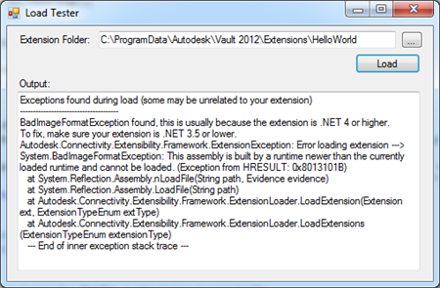
Click here to download the utility
The compiled EXE is in the bin\Release folder. The source code is provided too. It makes use of some loader utilities in Autodesk.Connectivity.Extensibility.Framework.

